

Know Your TX – Dissecting a Transaction   
  
**Objective/Aim:**  
  
To understand and analyze the structure of a blockchain transaction by viewing its details on a blockchain explorer.



**Apparatus/Software Used:**

* Laptop/PC
* MetaMask Wallet
* Blockchain Explorer (e.g Etherscan)
* Browser

**Theory/Concept:**

* **Transaction (TX):** A record of transfer of value or execution of smart contract on blockchain.
* **Blockchain Explorer:** A tool to view transaction details, wallet balances, and block data (e.g etherscan.io).
* **Key TX Fields:** TX Hash, From, To, Value, Gas Fee, Status, Block Number, Timestamp.



**Procedure:**

1.Open MetaMask click on the network selector at the top.

2.Select Sepolia Test Network.

3.Click on your MetaMask account name to copy your wallet address

4.Access Sepolia Faucet Website

5.Paste your copied MetaMask Sepolia address into the faucet input box.

6.Click on Request ETH

7.Wait for Transaction Confirmation

8. Open MetaMask, refresh, and see Sepolia ETH balance increased.

9.Click the transaction link from the faucet and check the details.

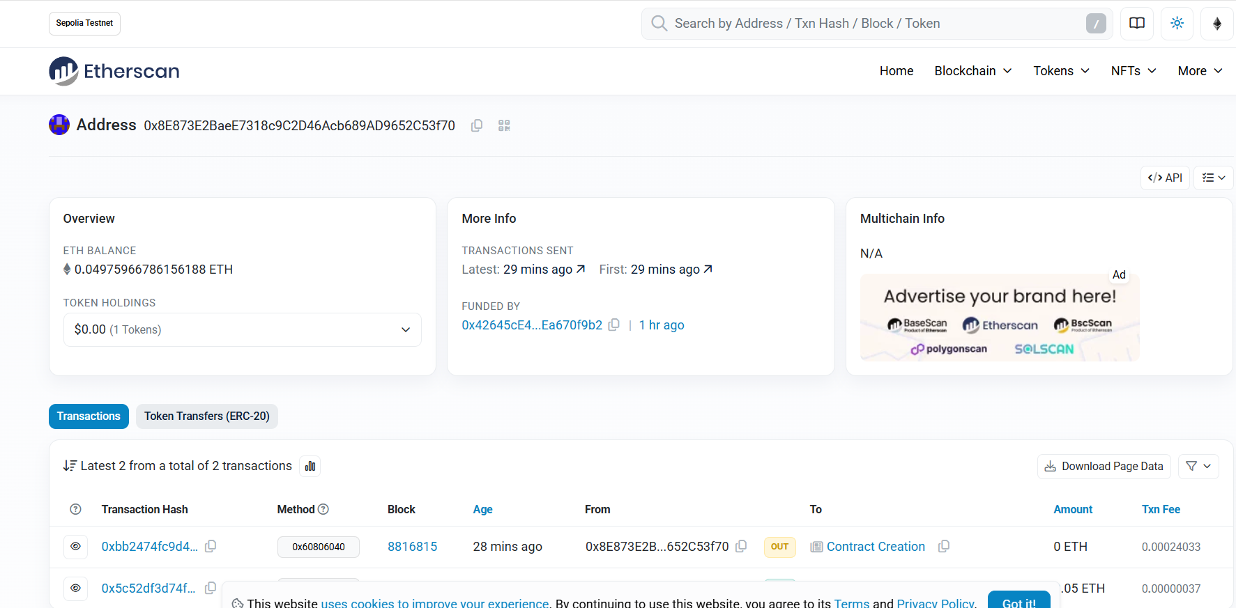

**Fig:- Transaction**

**Observation Table:-**

1.Wallet address copied and pasted on Sepolia Test Network.

2.ETH requested successfully.

3.Sepolia ETH received in MetaMask wallet after a few minutes.

4.Transaction verified on Sepolia Etherscan with successful status.

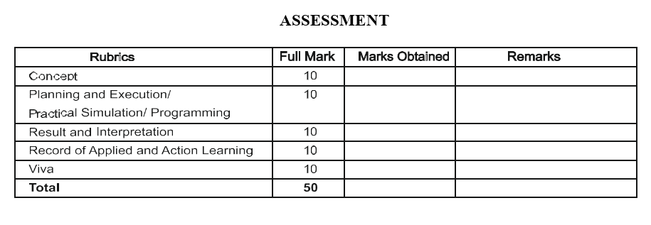

**Signature of the faculty: Signature of the Student:**

**Name:**

**Regn no:**